TABLE OF CONTENT
Table of Content i
CHAPTER ONE: INTRODUCTION 1
  - Background to the Study 1
  - Definition 1
  - Benefits of Big Data Platforms 1
  - Features of Big Data Platforms 1
  - Big Data platform to evaluate 1
  - Criteria for Evaluation 2
  - Investigation methodology 2
CHAPTER TWO: PLATFORM INVESTIGATION
2.1 Detailed report of evaluation on each platform according to the defined criteria 3
2.2 The comparation result 5
CHAPTER THREE: BIG DATA PROCESSING AND ANALYSIS IMPLEMENTATION 7
Explanations and Screenshots 7
3.1 EDA 7
3.2 Classification
3.3 Prediction
CHAPTER FOUR: CONCLUSION 8
Conclusion 8
REFERENCES 9

i
CHAPTER ONE
INTRODUCTION
1.1 Background to the Study
It's not clear when "data" became "big data." The latter word most likely emerged in Silicon Valley pitch meetings and lunch rooms in the 1990s. What's clearer is how data has surged in the twenty-first century — according to one estimate, people will generate 463 exabytes of data every day by 2025 — and how it's accounted for the growth in use of big data platforms.
Because the continual flood of data from numerous sources is only increasing, a slew of sophisticated and highly scalable cloud data platforms have come up to store and evaluate the ever-increasing volume of data. These systems are referred to as big data platforms.
1.2 Definition
A big data platform manages this volume of data, storing it in a way that is structured and comprehensible enough to derive important insights. Big data platforms gather data on a vast scale, often onto the cloud, using a mix of data management hardware and software tools.
1.3 Benefits of Big Data Platforms
How do Netflix or Spotify know what you want to watch next? This is mostly due to big data platforms at work behind the scenes.
Understanding big data has become a valuable tool in almost every business, from healthcare to retail and beyond. Companies are increasingly relying on these platforms to collect massive amounts of data and transform it into categorizable, actionable business choices. This allows businesses to gain a better understanding of their consumers, target audiences, find new markets, and make forecasts about future moves. Using enterprise data platforms not only provides a strong business advantage, but is almost paramount for keeping up with consumers, competing brands and ever-changing trends.
1.4 Features of Big Data Platforms
The inherent flexibility of big data systems makes them excellent for handling large amounts of data. The ability to accept the basic features of big data — volume, velocity, and diversity — is a must-have for these sorts of systems.
As a result, big data platform features often include the ability to be scalable, rapid, and equipped with built-in analytical tools to account for the information at hand. Some of the greatest big data platforms offer tools for handling enormous volumes of streaming or at-rest data, translating data between numerous data formats, and adding additional applications at any moment.
1.5 Big Data platform to evaluate
A. BigQuery (Google): Google Cloud provides a plethora of large data management solutions, each with its own specialization. BigQuery stores petabytes of data in a searchable fashion. Dataflow examines both live data streams and historical data batches in parallel. Clients may use Google Data Studio to create unique visualizations from a variety of data sources.
B. Azure (Microsoft): Users may analyze data stored on Microsoft's Azure cloud platform using a variety of open-source Apache technologies, including Hadoop and Spark. HDInsight, an Azure native analytics tool, speeds data cluster analysis and integrates seamlessly with Azure's other data tools.
1
C. MongoDB: MongoDB does not necessitate the entry of data into spreadsheets. Instead, its cloud-based services save data as flexible JSON documents, or digital objects that may be structured in a variety of ways, including nesting within one another. The platforms are intended for app developers and offer real-time search functionality. Users may search their data for geotags, graphs, and text phrases, for example.
D. Oracle: Oracle Cloud's big data technology, according to reports, can seamlessly and without downtime migrate multiple data types to cloud servers. The platform may also be utilised on-premises or in a hybrid environment, enriching and transforming data in real time or in a centralised repository known as a data lake. The platform also has a free layer.
1.6 Criteria for Evaluation
1. Does the technology support join, indexing and automated materialized views?
2. How does the scaling model provide for workload isolation?
3. Does the technology provide APIs to automate environment spin-up and spin-down?
4. Does the technology provide elastic scaling capabilities?
5. Is the offering built as IaaS or SaaS?
6. Does the technology support semi-structured data?
7. What are some recommended strategies for managing semi-structured data?
8. What is the granularity at which the platform operates?
1.7 Investigation methodology
A review of 4 big data ware house cloud platform using 8 criteria from fire bolt was investigated . This is a qualitative research and will focus on sources from the internet, articles and journals. The report was carried out by evaluating criteria for choosing a cloud ware house which can be determined by the organisation’s volume, velocity , veracity. If the data is structured, unstructured and semi structured by choosing the best platform to use and some determinant which are price, scalability, and security are factors to consider. The results will be compared in a tabular form and identify any similarities and differences.

2
CHAPTER TWO
PLATFORM INVESTIGATION
2.1 DETAILED REPORT OF EVALUATION ON EACH PLATFORM ACCORDING TO THE DEFINED CRITERIA.
1 Does the technology support join, indexing and automated materialized views?.
BigQuery (Google): Google Cloud provides a plethora of large data management solutions, each with its own specialisation. BigQuery stores petabytes of data in a searchable fashion. Dataflow examines both live data streams and historical data batches in parallel. Clients may use Google Data Studio to create unique visualisations from a variety of data sources.
Azure(Microsoft): Yes, the code demonstrates that Azure SQL enables the automatic usage of indexed views without the NOEXPAND hint. The blog item also includes a code sample that the author uses to back up their claim.
MongoDB: Despite the fact that MongoDB is not an RDBMS (Relational Database Management System) and does not include extensive join methods, you may join two collections in MongoDB using a variety of different operators. MongoDB indexes are basically similar to indexes in other database systems. MongoDB defines indexes at the collection level and supports indexes on any field or sub-field of the documents in a MongoDB collection. MongoDB has two types of views: normal views and on-demand materialised views. Both view types return aggregate pipeline results.
Oracle: A materialised view can be partitioned, and it can be defined on a partitioned table. On the materialised view, you may also declare one or more indexes.
2 How does the scaling model provide for workload isolation?
BigQuery (Google): By arranging calculations as an execution tree, BigQuery Architecture with Dremel can scale to thousands of computers. A root server accepts incoming queries and forwards them to branches, also known as mixers, which change the queries and distribute them to leaf nodes, also known as slots.
Azure(Microsoft): Scalability refers to a system's capacity to manage increased load. Azure Autoscale services may scale automatically in response to demand and workload. These services scale out to ensure capacity during workload peaks and return to regular operation as soon as the peak subsides.
MongoDB: Replica sets enable high availability as well as the ability to separate workloads. Data analysis and visualisation are ideal use cases for reading from secondary or dedicated analytics nodes, which MongoDB Charts now fully supports.
Oracle: Oracle's scaling approach provides workload segregation by the number of CPU cores or storage capacity.
3. Does the technology provide APIs to automate environment spin-up and spin-down?
BigQuery (Google): Allow developers to create fully provisioned environments using the UI, CLI, or API.

3
Azure(Microsoft): Azure API Apps provide as a platform for creating, hosting, and deploying APIs for cloud and on-premises infrastructure. It allows for the creation of an app that provides API-based application / software access, a link for SaaS / hybrid cloud settings, and a centralized API management platform.
MongoDB: NO, MongoDB does not provide APIs for automating the startup and shutdown of environments. MongoDB Atlas has a complete API, allowing CI/CD for the data platform itself.
Oracle: Oracle Integration Cloud provides Process Automation solutions that assist enterprise business and IT organisations in implementing business process initiatives aimed at automating business transactions that often involve humans and systems of record.
4. Does the technology provide elastic scaling capabilities?
BigQuery (Google): BigQuery is extremely adaptable. It swiftly and smoothly scales to any size. Furthermore, BigQuery is extremely cost effective, charging you just for the resources used rather than the resources installed or bargained in a contract.
Azure(Microsoft): Yes, you can easily scale out databases in Azure SQL Database using the Elastic Databasetools. These tools and features enable you to use the database resources of Azure SQL Database to build solutions for transactional workloads, notably Software as a Service (SaaS) applications. The number of VM instances that operate your application may be automatically increased or decreased by an Azure virtual machine scale configuration. This automatic and elastic behaviour eliminates the management overhead required to monitor and optimise your application's performance.
MongoDB: MongoDB has a comprehensive set of vertical, horizontal, and elastic scaling capabilities, which are included into MongoDB Atlas, the company's multi-cloud developer data platform.
Oracle: Oracle's Oracle Cloud Infrastructure platform includes many autoscaling services, including Compute Autoscaling and a flexible load balancer that offers elastic load balancing for network traffic.
5. Is the offering built as IaaS or SaaS?
BigQuery (Google): BigQuery is a Google SaaS business data warehouse that enables for the storage and querying of massive amounts of data.
Azure(Microsoft): Azure, Microsoft's cloud computing platform, offers Platform as a Service (PaaS) and Infrastructure as a Service (IaaS). They are crucial components for designing, deploying, and maintaining applications hosted on Azure or any other cloud computing platform, together with Software as a Service (SaaS).
MongoDB: MongoDB's product is designed as a Software as a Service (SaaS)
Oracle: Oracle Cloud provides Infrastructure as a Service (IaaS), Platform as a Service (PaaS), Software as a Service (SaaS), and Data as a Service (DaaS). These services are used to create, launch, integrate, and enhance cloud-based applications.
6. Does the technology support semi-structured data ?
BigQuery (Google): Yes, today we're launching a public preview of the BigQuery native JSON data type, which adds support for semi-structured data storage and analysis in BigQuery.

4
Azure(Microsoft): The Kusto Query Language, which is expressive, intuitive, and extremely productive, is used by Azure Data Explorer. It enables querying organised, semi-structured, and unstructured (text search) data and allows for a seamless transition from basic one-liners to complicated data processing scripts.
MongoDB: MongoDB, the most popular non-relational database, supports semi-structured documents by storing them natively in JSON format.
Oracle: By storing key-value pairs in NoSQL tables, Oracle NoSQL Database Cloud Service can store and handle semi-structured data. Semi-structured data is represented through XML.
7. What are some recommended strategies for managing semi-structured data?
BigQuery (Google): To store hierarchical data structures such as JSON documents, nested and repeated fields can be used.
Azure(Microsoft): Load semi-structured data without transformation: When connecting Storage and Cluster, the JSON Mappings function is utilised.
MongoDB: Semi-structured data can be stored in collections as JSON-like documents.
Oracle: Autonomous JSON Database accelerates the development of JSON-centric applications. Optimize Oracle Database workload performance, scalability, and consolidation efficiency.
8. What is the granularity at which the platform operates ?
BigQuery (Google): BigQuery runs at the project, dataset, and table levels.
Azure(Microsoft): Granularity The minimal temporal granularity is one minute, however the underlying technology may capture data faster depending on the measure. For example, the CPU % for an Azure VM is collected every 15 seconds.
MongoDB: MongoDB sets the granularity to "seconds" by default, indicating a high-frequency ingestion rate or the absence of a metaField.
Oracle: Oracle functions at the database, table, and row and column levels inside tables.

2.2 THE COMPARATION RESULT

 | Google BigQuery | Microsoft Azure | Oracle | MongoDB
Does the technology support join, indexing and automated materialized views? | YES | YES | YES | YES
How does the scaling model provide for workload isolation | supports scaling through the ability to increase or decrease the number of slots allocated to a specific project. | Azure SQL Database and Azure Synapse Analytics (formerly SQL Data Warehouse) | through the number of CPU cores or the amount of storage. | through the use of sharding
Does the technology provide APIs to automate environment spin-up and spin-down? | YES | YES | YES | YES
Does the technology provide elastic scaling capabilities? | YES | YES | YES | YES
Is the offering built as IaaS or SaaS? | BigQuery is a SaaS offering | Azure offers a mix of IaaS and SaaS offerings. | Oracle offers a mix of IaaS and SaaS offerings | MongoDB offers a mix of IaaS and SaaS offerings.
Does the technology support semi-structured data? | YES | YES | YES | YES
What are some recommended strategies for managing semi-structured data? | one can use nested and repeated fields to store hierarchical data structures, such as JSON documents | one can use the JSON data type to store the data as JSON documents. | one can use the JSON data type | MongoDB operates at the level of databases, collections, and documents
What is the granularity at which the platform operates? | BigQuery operates at the level of projects, datasets, and tables | Azure operates at the level of individual resources | Oracle operates at the level of databases, tables, and individual rows and columns within tables. | MongoDB operates at the level of databases, collections, and documents

6
CHAPTER THREE
BIG DATA PROCESSING AND ANALYSIS IMPLEMENTATION
Explanations and screenshots
3.1 EDA
EDA is a data analysis phenomenon that is used to acquire a better knowledge of data elements such as: - key properties of data - variables and relationships that hold between them - determining which variables are critical to our problem We will examine several exploratory data analysis strategies such as:
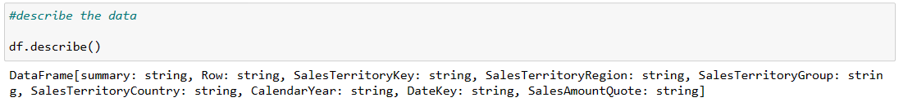
Figure 3.1: Data description
Figure 3.1 Above shows the description of the dataset used.

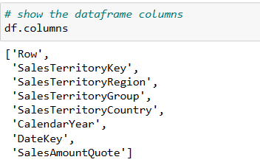
Figure 3.2: Dataframe columns
Figure 3.2 Above shows the columns of data frames in the dataset

7
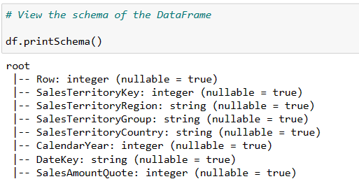
Figure 3.3: Schema of the dataframes
Figure 3.3 Above shows the Schema of the dataset which means it shows the structure of the dataset

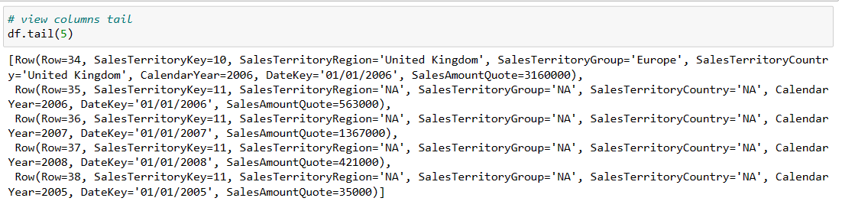
Figure 3.4: Columns tail
Figure 3.4 Above shows the tail of the columns
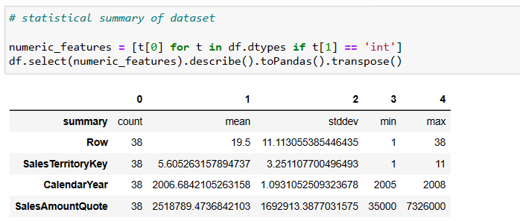
Figure 3.5: Statistical summary of dataset
8
Figure 3.5 Above shows the visualization for statistical summary of the dataset used for classification which shows counts, mean, standard deviation, minimum and maximum for each column in the dataset.

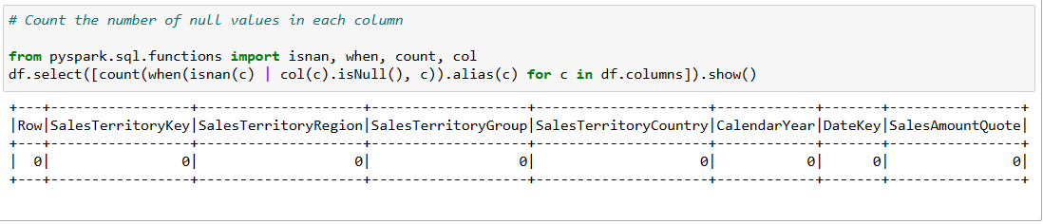
Figure 3.6: Number of null values
Figure 3.6 Shows the number of null values in the dataset which shows there is no null value in the used dataset.

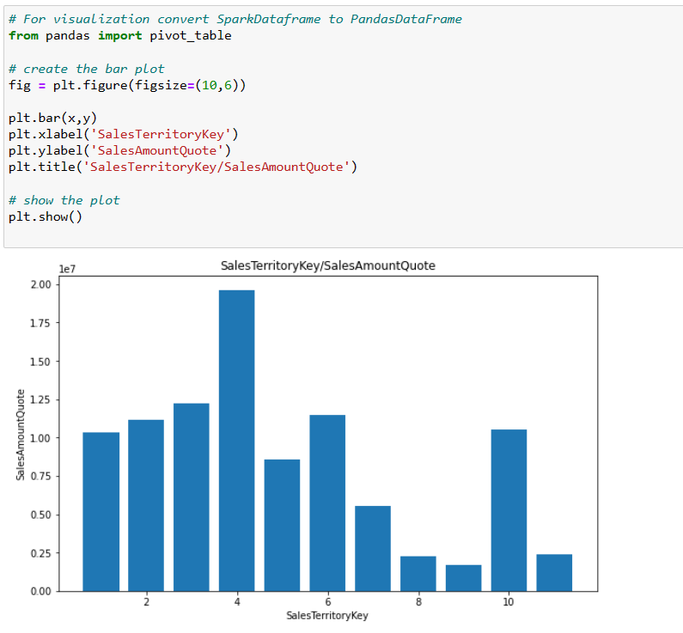
Figure 3.7: Bar plot of SalesTerritoryKey against SalesAmountQuote
Figure 3.7 Shows the Bar plot of Sales Territory Key against Sales Amount Quote and from my visualization output it shows that the sales amount quote is higher between 0 to 6.
9
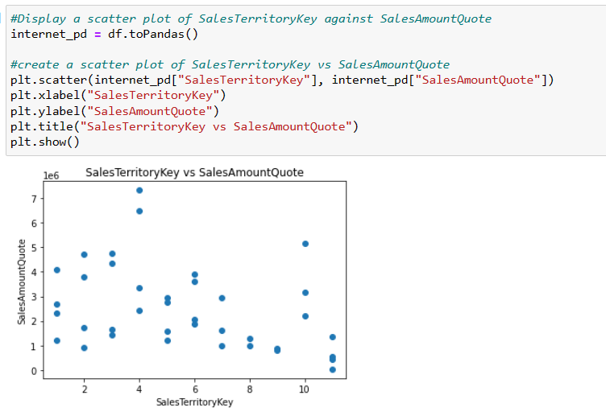
Figure 3.8: Scatter plot
Figure 3.8 shows scatter plot Sales Territory Key and Sales Amount Quote, however the scatter plot shows that there is positive weak correlation between them.

10
3.2 CLASSIFICATION
Classification algorithms are mainly used to identify the category of any given data set and predict the output for the absolute data, and for my classification I used Gradient-Boost Tree Classifier because it achieved the best result for my classification.

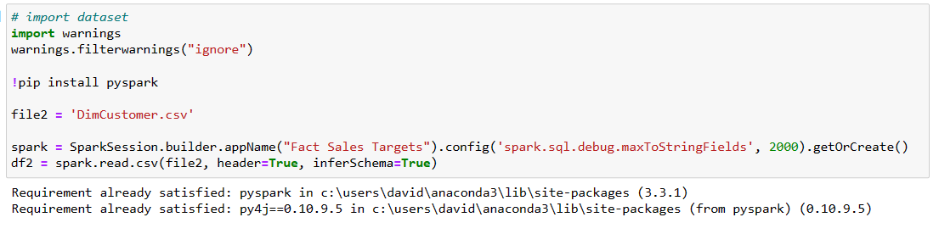
Figure 3.8: Dataset importation
Figure 3.8 Above shows the visualization of where the dataset I used for classification is imported

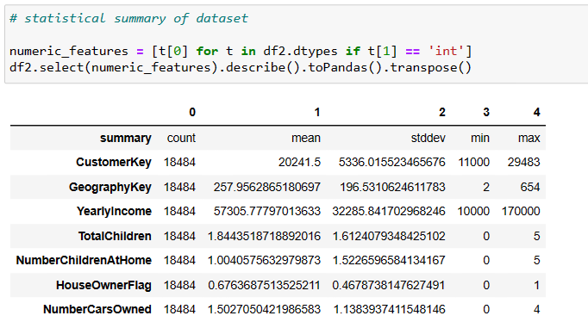
Figure 3.9: Statistical summary of dataset
Figure 3.9 Above shows the visualization for statistical summary of the dataset used for classification which shows counts, mean, standard deviation, minimum and maximum for each column in the dataset

11
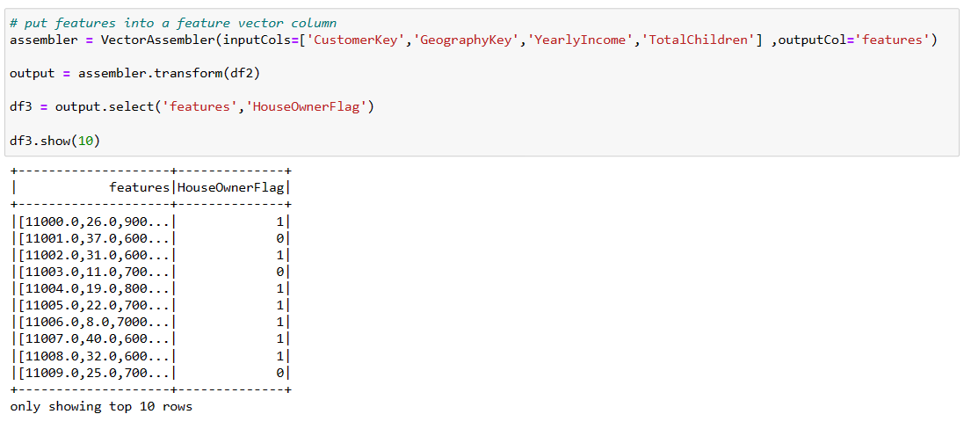
Figure 3.10: Feature vector column
Figure 3.10 The dataset's feature vector column is shown above. I designed the feature vectors to be used as input for models, allowing me to specify the feature vector once and then construct and track the datasets that resulted from it.

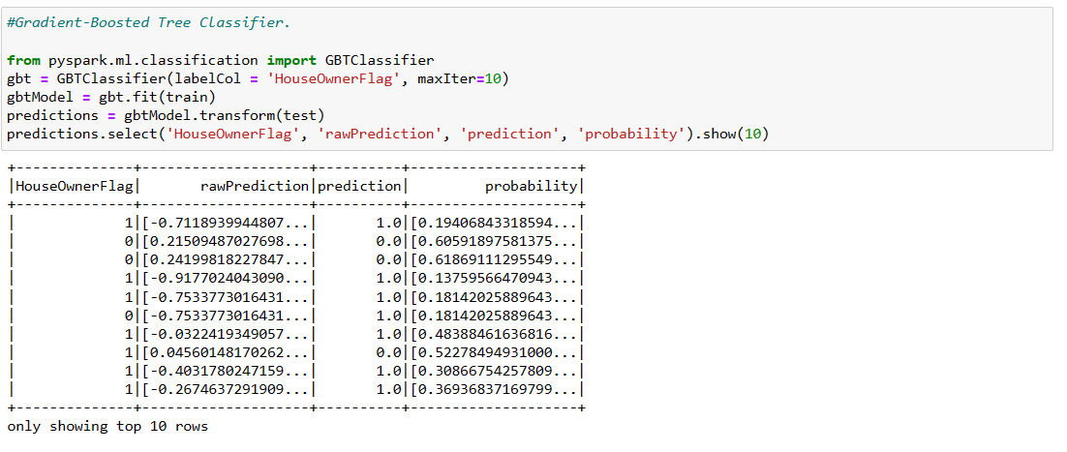
Figure 3.11: Gradient-Booted Tree Classifier
Figure 3.11 The image above depicts my output for rawprediction, prediction, and probability for the HouseOwnerFlag column.
12
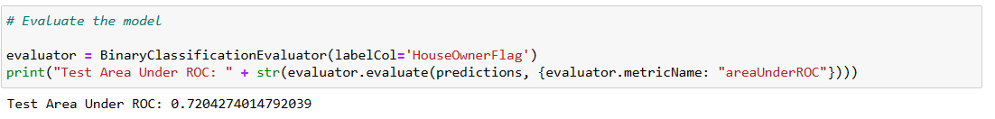
Figure 3.12: Test Area Under ROC
Figure 3.12 The test area under the ROC for the decision tree classifier is 0.72, and I chose Gradient-Boost Tree Classifier since it produced the best results for my classification.

13
3.3 PREDICTION
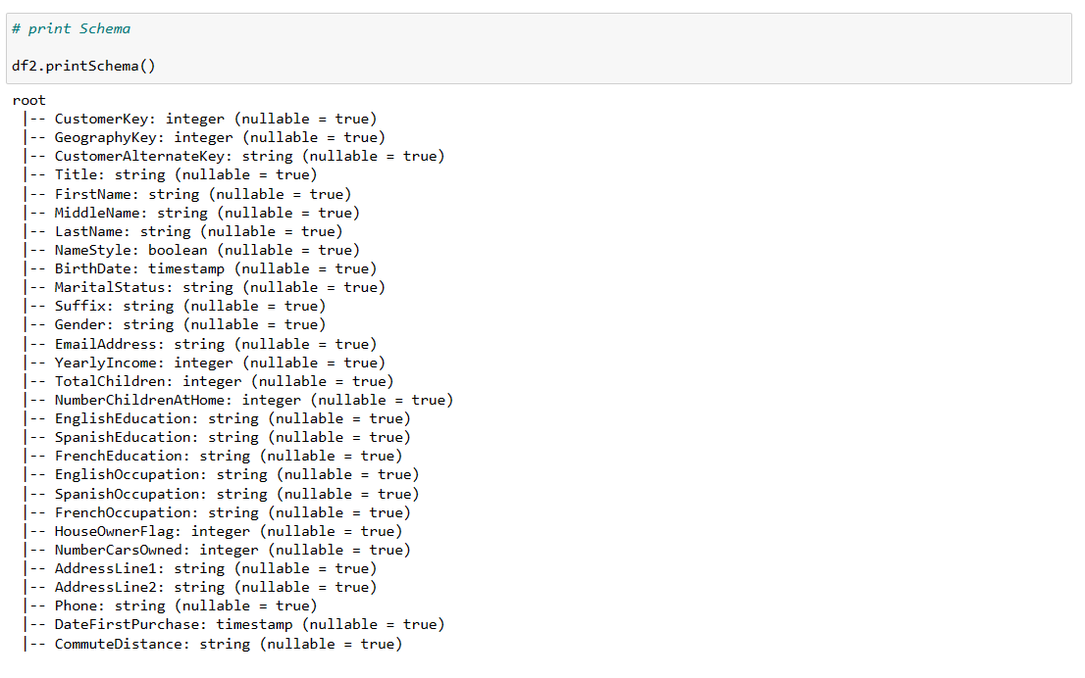
Figure 3.13: Schema of dataFrames
Figure 3.13 Above shows the Schema of the dataset which means it shows the structure of the dataset

14
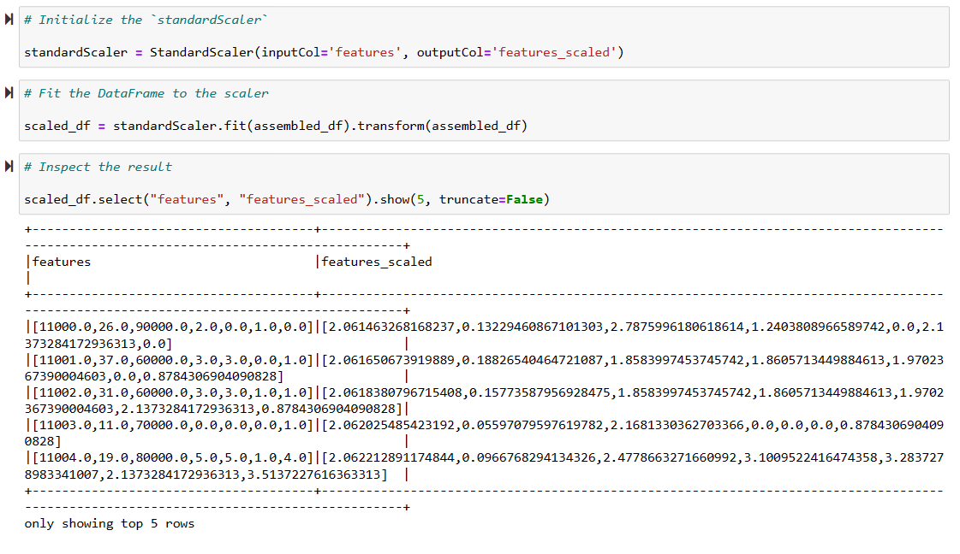
Figure 3.14: Standardization
Figure 3.14 The data was scaled using StandardScaler as seen above. The features are the input columns, and the output column with the rescaled that will be included in the scaled_df is called "features scaled."

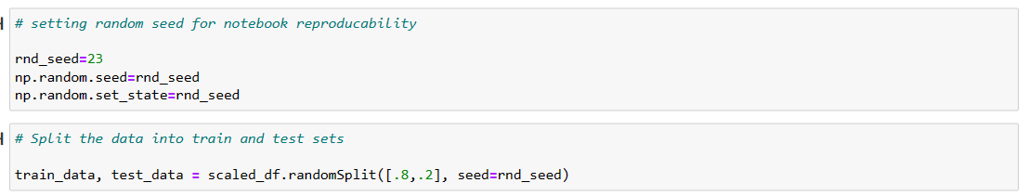
Figure 3.15: Split the data into train and test sets
We must first divide the data into training and test sets, as shown in Figure 3.15. I pass in a list including two integers representing the size of my training and test sets, as well as a seed, which is required for repeatability.
15
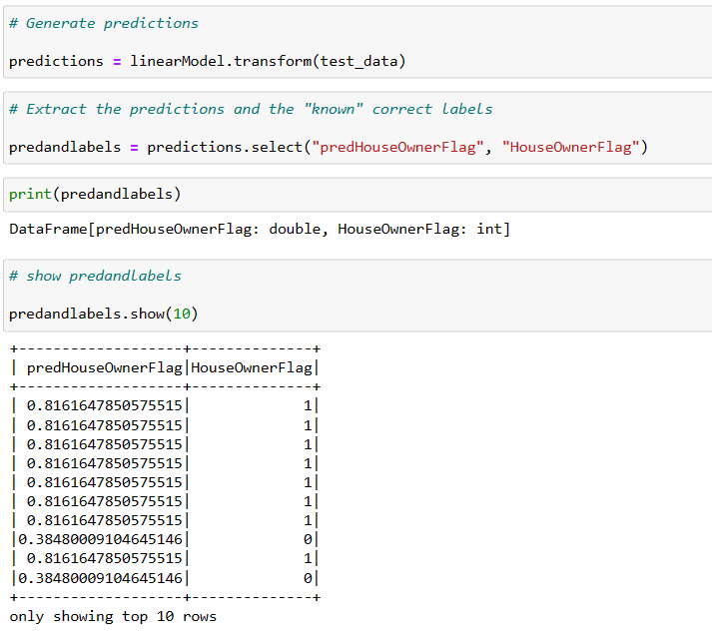
Figure 3.16: Generated Prediction
Figure 3.16 above shows the generated prediction for column of HouseOwnerFlag
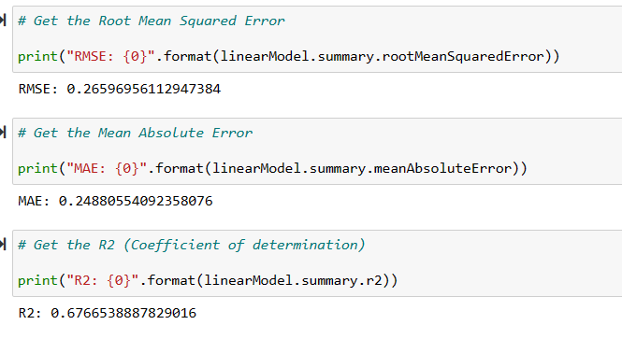
Figure 3.17: Metric Inspection

16
Fig. 3.17 Display the RMSE, which is 0.27, which evaluates the amount of error between two datasets when comparing a projected value to an observed or known value. The smaller the RMSE, the closer the predicted and observed values are. My RMSE is quite tiny, hence my projected values are very near.
The coefficient of determination, or R2 ("R squared"), is 0.6, and it indicates how near the data are to the fitted regression line. This score will always be between 0 and 100% (or 0 to 1), where 0% means the model explains none of the variability in the response data around its mean, and 100% means the model explains all of the variability. That is, the greater the R-squared, the better the model fits our data in general. However, my R-squares are large, indicating that my model fits better.

17
CHAPTER FOUR
CONCLUSION
It is important to note that the decision to use a big data cloud warehouse should be based on the specific needs of the organization and the type of data being stored. It is also important to consider security and compliance, as well as the potential for vendor lock-in. Overall, the use of a big data cloud warehouse can provide significant benefits for organizations looking to improve their data storage and management capabilities, but it should be carefully evaluated and implemented in a way that meets the specific needs of the organization. Moreso, the test area under the ROC for the decision tree classifier is 0.72, and I chose Gradient-Boost Tree Classifier since it produced the best results for my classification.

18
REFERENCES
What is Bigquery ML? | google cloud (no date) Google. Google. Available at: https://cloud.google.com/bigquery-ml/docs/introduction (Accessed: October 31, 2022).
BigQuery for Data Warehouse Practitioners | cloud architecture center | google cloud (no date) Google. Google. Available at: https://cloud.google.com/architecture/bigquery-data-warehouse (Accessed: October 31, 2022).
(no date) Google search. Google. Available at: https://www.google.com/search?q=does%2Bbig%2Bquery%2B%28google%29%2Btechnology%2Bsupport%2Bdata%2Bcompression%2C%2Bindexing%2Band%2Bpruning&rlz=1C1RXQR_enGB1027GB1027&oq=does%2Bbig%2Bquery%2B%28google%29%2Btechnology%2Bsupport%2Bdata%2Bcompression%2C%2Bindexing%2Band%2Bpruning&aqs=chrome..69i57.33923j0j4&sourceid=chrome&ie=UTF-8 (Accessed: October 31, 2022).
(no date) Google search. Google. Available at: https://www.google.com/search?q=does%2Bbig%2Bquery%2B%28google%29%2Btechnology%2Bsupport%2Bdata%2Bcompression%2C%2Bindexing%2Band%2Bpruning&rlz=1C1RXQR_enGB1027GB1027&oq=does%2Bbig%2Bquery%2B%28google%29%2Btechnology%2Bsupport%2Bdata%2Bcompression%2C%2Bindexing%2Band%2Bpruning&aqs=chrome..69i57.33923j0j4&sourceid=chrome&ie=UTF-8 (Accessed: October 31, 2022).
(no date) Google search. Google. Available at: https://www.google.com/search?q=does%2Bbig%2Bquery%2B%28google%29%2Btechnology%2Bsupport%2Bdata%2Bcompression%2C%2Bindexing%2Band%2Bpruning&rlz=1C1RXQR_enGB1027GB1027&oq=does%2Bbig%2Bquery%2B%28google%29%2Btechnology%2Bsupport%2Bdata%2Bcompression%2C%2Bindexing%2Band%2Bpruning&aqs=chrome..69i57.33923j0j4&sourceid=chrome&ie=UTF-8 (Accessed: October 31, 2022).
(no date) Google search. Google. Available at: https://www.google.com/search?q=does%2Bbig%2Bquery%2B%28google%29%2Btechnology%2Bsupport%2Bdata%2Bcompression%2C%2Bindexing%2Band%2Bpruning&rlz=1C1RXQR_enGB1027GB1027&oq=does%2Bbig%2Bquery%2B%28google%29%2Btechnology%2Bsupport%2Bdata%2Bcompression%2C%2Bindexing%2Band%2Bpruning&aqs=chrome..69i57.33923j0j4&sourceid=chrome&ie=UTF-8 (Accessed: October 31, 2022).
(no date) Google search. Google. Available at: https://www.google.com/search?q=does%2Bbig%2Bquery%2B%28google%29%2Btechnology%2Bsupport%2Bdata%2Bcompression%2C%2Bindexing%2Band%2Bpruning&rlz=1C1RXQR_enGB1027GB1027&oq=does%2Bbig%2Bquery%2B%28google%29%2Btechnology%2Bsupport%2Bdata%2Bcompression%2C%2Bindexing%2Band%2Bpruning&aqs=chrome..69i57.33923j0j4&sourceid=chrome&ie=UTF-8 (Accessed: October 31, 2022).
(no date) Google search. Google. Available at: https://www.google.com/search?q=does%2Bbig%2Bquery%2B%28google%29%2Btechnology%2Bsupport%2Bdata%2Bcompression%2C%2Bindexing%2Band%2Bpruning&rlz=1C1RXQR_enGB1027GB1027&oq=does%2Bbig%2Bquery%2B%28google%29%2Btechnology%2Bsupport%2Bdata%2Bcompression%2C%2Bindexing%2Band%2Bpruning&aqs=chrome..69i57.33923j0j4&sourceid=chrome&ie=UTF-8 (Accessed: October 31, 2022).

19
roygara (n.d.). Azure Premium Storage: Design for high performance - Azure Virtual Machines. [online] learn.microsoft.com. Available at: https://learn.microsoft.com/en-us/azure/virtual-machines/premium-storage-performance [Accessed 3 Nov. 2022].
learn.microsoft.com. (n.d.). How to move Semi-structured, Unstructured data formats(PDF format) into Synapse Workspace - Microsoft Q&A. [online] Available at: https://learn.microsoft.com/en-us/answers/questions/548219/how-to-move-semi-structured-unstructured-data-form.html [Accessed 3 Nov. 2022].
www.peerspot.com. (n.d.). What is your primary use case for Microsoft Azure DevOps? [online] Available at: https://www.peerspot.com/questions/what-is-your-primary-use-case-for-microsoft-azure-devops [Accessed 3 Nov. 2022].
MongoDB. (n.d.). Workload Isolation with Atlas and Charts | MongoDB Blog. [online] Available at: https://www.mongodb.com/blog/post/workload-isolation-with-atlas-and-charts [Accessed 5 Nov. 2022].

20

